
ACKNOWLEDGEMENTS

Prior to signing a sale and purchase agreement, we recommend that you seek legal / technical advice.

Vendor Initials: Purchaser Initials:

Please read and sign this form before commencing the purchase process or bidding at auction.

Property Address: 12 Victory Road, Laingholm

Vendor: Sophie Gao & Conner Bond

Purchaser:

REA REQUIREMENTS:
You are entering into this transaction voluntarily and without duress.
We have made you aware that we have an in-house complaints procedure, and provided you with the following documents: REA Code of Conduct I REA Guide to Selling and Buying I OIA Information Sheet

AML & OIA:
You will have Anti Money Laundering obligations under the AML Act 2009 and may also have OIA obligations under the Overseas Investment Amendment Act 2021 (information sheet provided).
You will need to provide to your Solicitor, a NZ IRD number and NZ bank account number, to complete the sale.
IF YOU ARE UNCERTAIN ABOUT YOUR ELIGIBILITY, YOU MUST NOT BID AT AUCTION, AND SHOULD MAKE YOUR OFFER SUBJECT TO OBTAINING OVERSEAS INVESTMENT OFFICE CONSENT.

RELATED PARTY TRANSACTION:
We will advise you in writing if the owner (or any party associated with the owner) is a salesperson or employee of Austar Realty or is related to any such salesperson or employee.

BOUNDARIES:
The salesperson cannot, and therefore has not, defined the property boundaries.

MULTI OFFERS:
We acknowledge that this can be a high stakes and stressful process for buyers. As such, we have a set Multi Offer process in place, and specific documentation that will be strictly followed for multi offers.

TITLE:
We have provided you with the certificate of title for the property, and any relevant interests or instruments. If the property is a cross lease, we have provided you with the flats plan, and the memorandum of lease. If the property is a unit title, we have provided you with the pre contract disclosure statement.

PROFESSIONAL REPORTS:
Even if the vendor has already supplied a third-party builder’s report, we recommend that you obtain independent professional reports on the property, if you have any doubts about its condition.

Vendor Signature(s)______________________________________________ _

Date:

Purchaser Signature(s)______________________________________________ _

Date:
DISCLOSURES

IMPORTANT: This is a living document that may change several times before sale day. Please ensure you read and download the most up to date version before making an offer or bidding at auction.
This document was updated on: 14 January 2026

Interest: During marketing campaigns, dates and timeframes sometimes change. Please register your interest with us as early as possible so you don’t miss out on purchasing the property.
We have made available to you the following:
- Certificate of Title
- LIM
- Rates information from Auckland Council
- School Zones
- REA Code of Conduct
- REA Guide to Selling and Buying
- Sale & Purchase Agreement

Known defects associated with the property:

Other disclosures that may be important to purchasers:

The deck and shed encroach onto neighboring properties (see attached survey plan). This was like this when the previous owners and the current vendors purchased the property. The land being encroached on is in the bush parts of their sections away from the house.

It appears that the layout of the downstairs area is different to what was on the original plans. We have not sighted any documentation to show when this was done, and the vendors purchased the property with the current layout.

Vendor Circumstances - The Vendor has given us permission to disclose the following personal information:

Moving On

Additional Information:

THINGS WE WANT TO DRAW YOUR ATTENTION TO:
Land Information Memorandum (LIM)
We have summarised what we believe are the important points in the LIM however we strongly recommend that you read the entire document and seek legal advice.

Wind Zones for this property |  | Very high wind speed of 50 m/s
Soil Issues |  | 30/06/2000 Stability Sensitive: Please note this property was previously shown under the Transitional District Plan as being located in a Stability sensitive area.  Stability sensitive - Titirangi and Laingholm is stability sensitive. This means that should you develop the property, you will require an engineer’s report.
Planning |  | LUC-1987-26561 Land Use Consent Erect A Domestic Garage Granted 18/06/1987
Building |  | BPM-1983-21897 Dwelling 31/12/1983 Issued  BPM-1987-34060 Garage 31/12/1987 Issued
Waitakere Ranges Heritage Area | This property is located within the Waitākere Ranges Heritage Area as defined in the Waitākere Ranges Heritage Area Act 2008.
Zoning | Large Lot Zone
Controls | Controls: Macroinvertebrate Community Index - Urban  Controls: Stormwater Management Area Control - TITIRANGI / LAINGHOLM 1 - Flow 1
Overlays | Natural Heritage: Ridgeline Protection Overlay - Modified  Natural Heritage: Waitakere Ranges Heritage Area Overlay - Extent of Overlay  Natural Heritage: Waitakere Ranges Heritage Area Overlay - WRHA_06 - Subdivision Schedule

Settlement Date on Offer: As soon as possible

We recommend that you get a building inspection report. We also recommend that when purchasing a property, you seek legal advice, complete due diligence and arrange your finance.

This information has been supplied to us by a third party. Accordingly, the Vendor and Austar Reality Limited are merely passing over this information as supplied to us by others. While we have passed on this information supplied by a third party, we have not checked, audited, or reviewed records or documents and therefor to the maximum extent permitted by law neither the Vendor nor Austar Realty Limited or any of its’ salespersons or employees accept any responsibility for the accuracy of the materials. Intending purchasers are advised to conduct their own investigation.

Vendor Signature(s)______________________________________________ _

Date:

Purchaser Signature(s)______________________________________________ _

Date:

Salesperson Name:

Signature: Date:

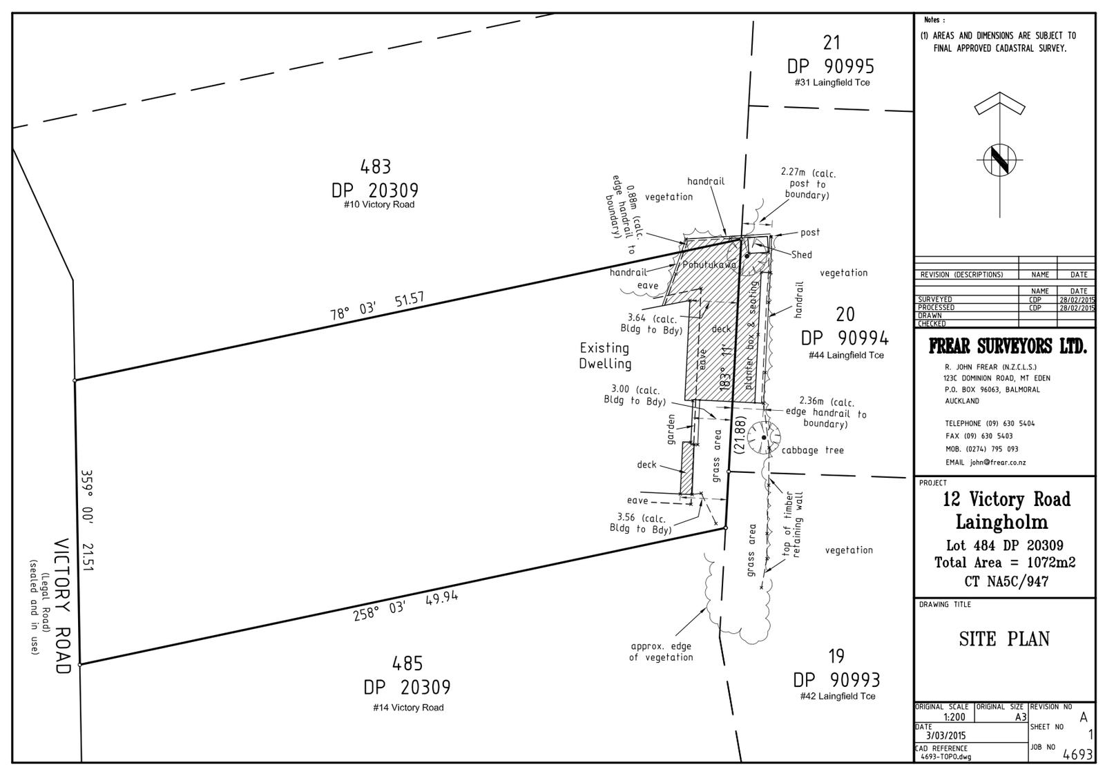




Austar Realty Ltd Complaints & Disputes Resolution Procedure

In accordance with Rule 12 Real Estate Agents Act (Professional Conduct and Client Care Rules) 2012, all licensed real estate agents are required to have a written in‐house complaints and dispute resolution procedure.
You do not have to use our complaints and resolution procedure. You may make a complaint directly to the Real Estate Agents Authority at any time. You can make a complaint to the Real Estate Agents Authority even if you choose to also use our procedures.
Our complaints and dispute resolution procedure is designed to provide a simple and personalised process for resolving any concern or complaint you might have about the service you have received from Austar Realty, or any of our licensees.

- Call the branch manager and give them the details of who you are complaining about, what your concerns are, and how you would like the issue resolved.
- The manager may ask you to put your complaint in writing so that he or she can investigate it. The manager will need a brief period of time to talk to the team members involved, and document their response. We promise to come back to you within 5 working days with a response to your complaint. That response may be in writing.
As part of that response we might ask you to meet with a senior manager or our CEO to discuss the complaint and try to agree on a resolution.
- If we are unable to come to an agreed resolution after a meeting, or if you don’t wish to meet with us, we may provide you with a written proposal to resolve your complaint.
- If you do not accept our proposal, please try and advise us in writing within five working days. You can, of course, suggest another way of resolving your complaint.
- If we accept your preferred resolution, we will attempt to implement that resolution as soon as possible. If we decline your preferred resolution, we may invite you to mediate the dispute.
- If we agree to mediate the complaint but don’t settle the complaint at mediation, or we do not agree to mediate the dispute, then that will be the end of our process.

Remember: You can still make a complaint to the Real Estate Agents Authority in the first instance and, even if you use our procedures, you can still make a complaint to the Real Estate Agents Authority at any time.
The Real Estate Authority Level 4 The Todd Building 95 Customhouse Quay
Wellington 6011
Phone 0800 367 732

